Joinery Unit Quiz

Multiple Choice directions: Read each question or statement carefully and then select the response that best satisfies that question or statement.

1. Rabbet joints are used on
A. antiques.
B. modern construction.
C. cabinet doors.
D. where glass is installed.

2. The rabbet joint on the bread box was cut using the
A. table saw.
B. radial arm saw.
C. router.
D. drill.

3. All angles in a square or rectangle must equal ________ degrees.
A. 45
B. 90
C.180
D. 360

4. Miter joints _________ the end grain of both joining boards.
A. hide
B. expose
C. enhance
D. complete

5. A type of joint that is a three sided groove across the grain is called a _______.
A. dado
B. rabbet
C. lap
D. miter

6. Most joints in woodworking are held together with
A. nails.
B. screws.
C. glue.
D. dowels.

7. The primary joint that holds the bread box together is called a _________ joint.
A. miter
B. dado
C. lap
D. dowel

8. A type of wood joint where equal amounts of wood are cut from both joints is called a _________ joint.
A. dado
B. miter
C. rabbet
D. lap

9. These are the weakest of all wood joints.
A. butt
B. dado
C. lap
D. rabbet

10. Round rods of wood or pegs that are used to strengthen wood joints are called
A. glue.
B. plugs.
C. nails.
D. dowels.

11. Gluing up many thin unusable wood strips to make a large plank is called an
A. dado joint.
B. edge butt joint.
C. dowel joint.
D. end lap joint.

12. The joint on the back of the bread box that is for the backing material to be placed into is called a
A. Dado joint.
B. Lap joint.
C. Miter joint.
D. Rabbet joint.

13. The joint pictured here is called a
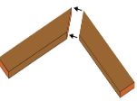
A. Dado joint.
B. Lap joint.
C. Miter joint.
D. Rabbet joint.

14. The joint pictured here is called a
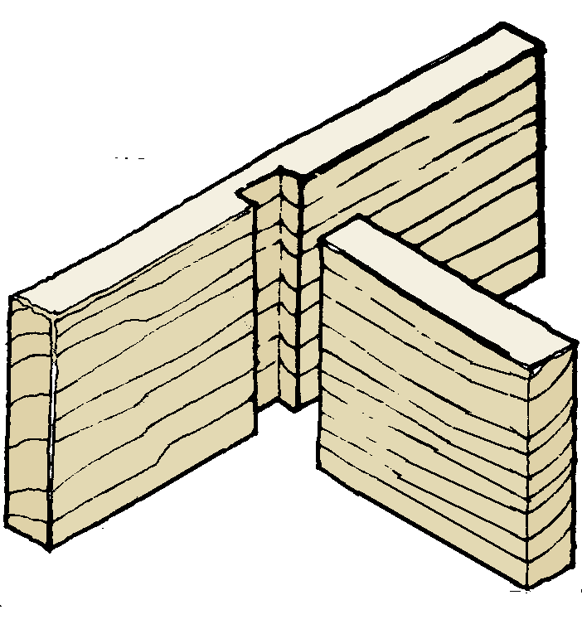
A. Dado joint.
B. Lap joint.
C. Miter joint.
D. Rabbet joint.

15. The joint pictured here is called a
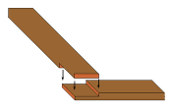
A. Dado joint.
B. Lap joint.
C. Miter joint.
D. Rabbet joint.

16. The joint pictured here is called a
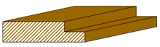
A. Dado joint.
B. Lap joint.
C. Miter joint.
D. Rabbet joint.
17. The joint pictured here is called a
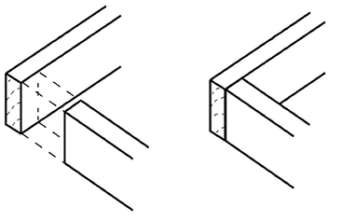
A. Miter joint.
B. Dado joint.
C. Butt joint.
D. Compression joint.

18. All of the following are lap joints except which one?
A. edge cross lap
B. end lap
C. half lap
D. rabbet lap

19. Blind Dados were used on what part of the bread box?
A. back edges
B. front corners of the sides
C. back corners of the top and bottom
D. top and bottom of the top and bottom

20. The width of most joints is _________ to the thickness of the joining stock.
A. 1/4
B. 1/2
C. equal
D. always less
E. always greater

fd: joinery unit quiz

